**Project 9: Northern Driving School Management System**

**About the Client**

Northern Driving School has been a leader in learner training and driving tests in the inner city areas, which include the many bay side areas, Melbourne CBD, and northern suburbs.

A fresh and exciting approach to driving education, Northern Driving School offers a professional and highly qualified instructing method that will enable learners to confidently enter the Victorian road system. Most importantly, learners will attain valuable skills and knowledge, which will guide them to becoming competent and safe drivers.

Expert instructors are all qualified driving instructors, up to date with the latest driver training assessment qualifications (Certificate IV Accreditation).

All of our instructors are full time professionals working with our school. They all have working with children identification cards, medical driving checks, police checks and they are all members of the Australian Driver Trainers Association. (A.D.T.A.V).

Our instructors offer a professional teaching method to learners, fully licenced drivers and overseas licence holders which includes variety of effective teaching aids such as diagrams, charts, driver training videos, booklets and of course thoroughly covering the VicRoads Drive Test criteria.

We also use reliable training record and assessment tools such as our student record sheets* and our practice driving test sheets*, which provide a detailed and up to date analysis and measurement of learner/driver progress and competency through the duration of lessons and leading up to test day.

**Project Brief & Business Problem Specifications:**

Northern Driving school Management System should manage practically all of the duties that driving schools perform on a regular basis. Physical books are still being used by the driving school to plan classes and retain data. This method is antiquated, unreliable, difficult to access, and occasionally inaccurate.

Northern Driving School Management System should be created specifically to address that issue. This should be a comprehensive driving school management system that could handle practically all of the responsibilities that driving school faces on a regular basis.

**System Modules Requirements**

* **Scheduling:** Class scheduling is an important part of every driving school. The system should allow school to create class schedules and monitor them. This features should help prevent double booking of time slots and should have a beautiful calendar to display all classes. Also an SMS could be sent to students when they are booked in for a class.
* **Student Management**: The system should be able to keep all student records in a way that can be accessed them from anywhere.System users could be able search through them easily and be able to check all the details of a specific student.
* **Notes and attachments:** System users could create and upload notes on a profile of a students, staff or instructor.
* **Instructors:** Instructors of courses should also have accounts where they can login and check their schedule.
* **Branches:** Northern driving school have branches and that should be covered on this. System users should be able to create as many branches of driving school as they want and manage them easily.
* **Admin/Stats dashboards:** Northern Driving school management system should have a stunning dashboard that shows the important statistics of the school.
* **Invoice Management:** When a student account is created and they sign up for a course. An invoice should be created and sent to them. Admin can keep track of all the invoices and see pending balances. Admin can download, edit and add payments to invoices as well
* **Payments:** Keep a record of all the payments received for future reference as well as update the invoice automatically.
* **Reminders:** Send reminder of late payments and also reminders of upcoming classes to students
* **Fleets:** Keep a record of all your fleet for easy assignment as well as check its schedule.
* **Notifications.** This saves and shows notifications of important activities of your driving school.
* **Communications:** This features should allow the driving school to send SMS or Email to their students, staff, instructors or all users on the system by a click of a button. The history of the messages should be kept for future reference.
* **Courses:** The system should keep a list of courses with details like price, number of classes, instructors etc. This list could be used when signing up new students to Northern driving school.
* **Staff:** The staff module should allow driving school to create accounts for their employees where they can manage daily operations of the school
* **Multi user:** You can build a saas software with Driving School Management System since it supports multiple school accounts.
* **Beautiful and responsive UI:** The system should have a stunning and beautiful responsive design.
* **Fast processing speed:** The system should be faster with clean code with MVC model.

**User Modules (User Frontend):**

Developers need to research and discuss with the client to finalise the modules and requirements.

**UI Design**

User Interface Design is concerned with the dialogue between a user and the computer. It is concerned with everything from starting the system or logging into the system to the eventually presentation of desired inputs and outputs. The overall flow of screens and messages is called a dialogue.

**UI Design Requirements**

1. The system user should always be aware of what to do next.
2. The screen should be formatted so that various types of information, instructions and messages always appear in the same general display area.
3. Message, instructions or information should be displayed long enough to allow the system user to read them.
4. Use display attributes sparingly.
5. Default values for fields and answers to be entered by the user should be specified.
6. A user should not be allowed to proceed without correcting an error.
7. The system user should never get an operating system message or fatal error.

The aim of proposed system is to develop a system of improved facilities. The proposed system can overcome all the limitations of the existing system. The system provides proper security and reduces the manual work.

* + Security of data.
  + Ensure data accuracy's
  + Proper control of the higher officials.
  + Minimize manual data entry.
  + Minimum time needed for the various processing.
* Greater efficiency.
* Better service.
  + User friendliness and interactive.
  + Minimum time required.

**Functional Requirements**

**E-Signatures**

**Classroom and In-Car Signatures**

The system should help meet proper social distancing guidelines and provide additional protection for students and staff by enabling students to sign their in-car signing sheet via student center. The system will eliminate passing papers, pens, or even mobile devices between student and instructor.

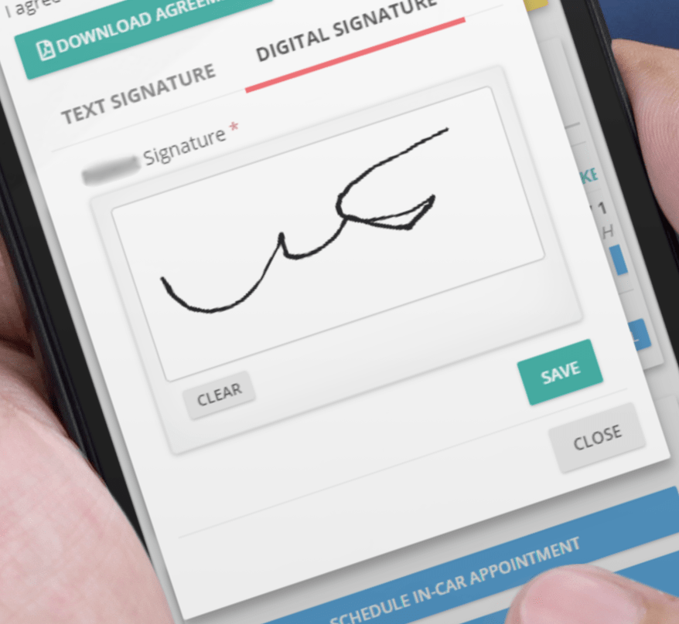

**Security and Validation**

Each signature is tied to specific student, lesson and instructor, and is date and time stamped for additional security. So when audit comes you will pass with ease.

**Scheduling**

The user should View all instructors’ schedules on a single screen. Easily book or reschedule lessons by simply dragging lessons from one staff to another. User can also see, student details, vehicle allocation and availability and more. It should be all in one place.

**Online Booking**

Students and parents should be able to view and book lessons from any device any time. Dramatically reducing phone calls and strain on the office staff.

**Late-Cancel-Booking**

This feature will increase school's productivity, efficiency and revenue. Open slots should be booked in as little as 5 minutes.

**Eliminate Double Booking**

Our software should prevent users or team members from double booking staff or vehicles. All the staff or vehicle availability should be visible with a click of a button. With a glance check the availability of team members and schedule them with confidence.

**Class and Driving Lesson Reminders**

System should send automatic lesson and classroom session reminders via email or text.

**Billing**

**Financial Tracking**

The system should offer complete tracking of students' financials. Everything from processing of credit cards, recording cash, checks and discounts. Financial reports should also be included and extremely flexible.

**Online Payments**

If students have open balance, they should be able to log into their account and pay the open balance anytime. Their account should be automatically adjusted and school should directly receive funds.

**Credit Card Processing**

The system should be fully integrated with industry leaders in merchant account and credit card processing. This integration should allow to process credit card transaction securely and safely with funds directly deposited into school’s account.

**Student Profile**

With custom set student profile the system should be able to track all important information related to each student. Anything from student contact information, permit and license information to notes and account to-dos.

**All In One Place**

All of the student information should be available at a glance. Anything from billing, appointments and notes.

Functional requirements are product features or functions that developers must implement to enable users to accomplish their tasks. So, it’s important to make them clear for the stakeholders. Generally, functional requirements describe system behavior under specific conditions. The developers of this system must enhance the performance and efficiency of the system by adding 15 to 20 more functional requirements. Students need to do their own research to find how they can improve the system and which FRs need to added. The group must need a prior approval from the stakeholders/project supervisor before finalizing these Functional Requirements. These enhanced FRs must be reflected separately in Final SRS Report after the approval.

**Hardware Requirement: Should be recommended by the developers.**

**Software Requirement: Should be recommended by the developers.**